Project Proposal for the
Smart Surveillance Technology
by


Javier Ocasio Pérez, Project Manager, sec. 031
William Sanchez Rosa, sec. 031
Abraham Díaz Santiago, sec. 031
Mariel Martínez Marrero, sec. 030

Dr. Fernando Vega and Dr. Nayda G. Santiago
ICOM 5047 sections 030 and 031

September 10, 2008

Abstract

Surveillance of equipment prone to theft and damage in places like laboratories, universities and hospitals, is an important topic nowadays, as current technologies are not enough to solve the problem. The use of security guards, CCTV (close circuit television) and other technologies like cameras and software alone has not stopped the crime and damage rates [1]. For example, in the past 3 years, the University of Puerto Rico at Mayagüez reported 394 crimes of theft and damage to property, which has summed up to a loss of $125,000 [2]. The majority of the reported stolen equipment were computers, office tools and special laboratory equipment. Surveillance is not only beneficial for areas where equipment can be tampered with, and where its quality can be compromised, it can also be used for monitoring processes that can go on unattended.
We are proposing to develop a prototype for surveillance of highly sensitive equipment prone to theft and damage. The idea, called Smart Surveillance Technology (SST), will allow the customer to monitor an area via a web page interface; permitting the user to be connected from any device that uses Internet. The technology will alert the person whenever someone has entered the monitored area at a schedule not assigned to the system. SST will be able to alert with alarms, sending e-mails and text messages via SMS. The system will give the opportunity to the customer to make a quick decision about the situation.
Table of Contents

Abstract . . . . . . . . . . . . . . . . . . . . . . . . . . . . . . . . . . . . . . . . . . . . . . . . . . . . . . . . . . . . . . . . . . 2

Figures Index . . . . . . . . . . . . . . . . . . . . . . . . . . . . . . . . . . . . . . . . . . . . . . . . . . . . . . . . . . . . . . 5

Tables Index . . . . . . . . . . . . . . . . . . . . . . . . . . . . . . . . . . . . . . . . . . . . . . . . . . . . . . . . . . . . . . . 6

- Executive Summary . . . . . . . . . . . . . . . . . . . . . . . . . . . . . . . . . . . . . . . . . . . . . . . . . . . . . . 7
  - Project Name . . . . . . . . . . . . . . . . . . . . . . . . . . . . . . . . . . . . . . . . . . . . . . . . . . . . . . . . 7
  - Team . . . . . . . . . . . . . . . . . . . . . . . . . . . . . . . . . . . . . . . . . . . . . . . . . . . . . . . . . . . . . . . 7
  - Introduction . . . . . . . . . . . . . . . . . . . . . . . . . . . . . . . . . . . . . . . . . . . . . . . . . . . . . . . . . 7
  - Document Description. . . . . . . . . . . . . . . . . . . . . . . . . . . . . . . . . . . . . . . . . . . . . . . . . . 8
  - Deliverables . . . . . . . . . . . . . . . . . . . . . . . . . . . . . . . . . . . . . . . . . . . . . . . . . . . . . . . . . 9
  - Milestones. . . . . . . . . . . . . . . . . . . . . . . . . . . . . . . . . . . . . . . . . . . . . . . . . . . . . . . . . . . 9
  - Key Economic Aspects . . . . . . . . . . . . . . . . . . . . . . . . . . . . . . . . . . . . . . . . . . . . . . . . .10
- Project Antecedents. . . . . . . . . . . . . . . . . . . . . . . . . . . . . . . . . . . . . . . . . . . . . . . . . . . . . . 10
  - Market Description . . . . . . . . . . . . . . . . . . . . . . . . . . . . . . . . . . . . . . . . . . . . . . . . . . . 10
  - Project Importance. . . . . . . . . . . . . . . . . . . . . . . . . . . . . . . . . . . . . . . . . . . . . . . . . . . . 11
- Proposed Solution . . . . . . . . . . . . . . . . . . . . . . . . . . . . . . . . . . . . . . . . . . . . . . . . . . . . . . . 12
  - Objectives . . . . . . . . . . . . . . . . . . . . . . . . . . . . . . . . . . . . . . . . . . . . . . . . . . . . . . . . . . 12
  - Problem Statement . . . . . . . . . . . . . . . . . . . . . . . . . . . . . . . . . . . . . . . . . . . . . . . . . . . .12
  - Possible Solutions. . . . . . . . . . . . . . . . . . . . . . . . . . . . . . . . . . . . . . . . . . . . . . . . . . . . .13
  - Solution. . . . . . . . . . . . . . . . . . . . . . . . . . . . . . . . . . . . . . . . . . . . . . . . . . . . . . . . . . . . .13
  - System Limitations . . . . . . . . . . . . . . . . . . . . . . . . . . . . . . . . . . . . . . . . . . . . . . . . . . . 14
- Design Specifications . . . . . . . . . . . . . . . . . . . . . . . . . . . . . . . . . . . . . . . . . . . . . . . . . . . . 15
  - Hardware. . . . . . . . . . . . . . . . . . . . . . . . . . . . . . . . . . . . . . . . . . . . . . . . . . . . . . . . . . . 16
    - Flow chart . . . . . . . . . . . . . . . . . . . . . . . . . . . . . . . . . . . . . . . . . . . . . . . . . . . . .17
    - Solution . . . . . . . . . . . . . . . . . . . . . . . . . . . . . . . . . . . . . . . . . . . . . . . . . . . . . . .18
      - Temperature Sensor . . . . . . . . . . . . . . . . . . . . . . . . . . . . . . . . . . . . . . . .18
      - Fire Sensor . . . . . . . . . . . . . . . . . . . . . . . . . . . . . . . . . . . . . . . . . . . . . . .18
      - Camera . . . . . . . . . . . . . . . . . . . . . . . . . . . . . . . . . . . . . . . . . . . . . . . . . .19
      - Microprocessor . . . . . . . . . . . . . . . . . . . . . . . . . . . . . . . . . . . . . . . . . . . 20
      - Alarm . . . . . . . . . . . . . . . . . . . . . . . . . . . . . . . . . . . . . . . . . . . . . . . . . . .21
  - Software . . . . . . . . . . . . . . . . . . . . . . . . . . . . . . . . . . . . . . . . . . . . . . . . . . . . . . . . . . . .21
    - Flow Chart . . . . . . . . . . . . . . . . . . . . . . . . . . . . . . . . . . . . . . . . . . . . . . . . . . . . 22
    - Solution. . . . . . . . . . . . . . . . . . . . . . . . . . . . . . . . . . . . . . . . . . . . . . . . . . . . . . 23
      - Main Application Service. . . . . . . . . . . . . . . . . . . . . . . . . . . . . . . . . . . 23
      - Web Application Interface. . . . . . . . . . . . . . . . . . . . . . . . . . . . . . . . . . .23
      - Data Base . . . . . . . . . . . . . . . . . . . . . . . . . . . . . . . . . . . . . . . . . . . . . . . 23
- Schedule . . . . . . . . . . . . . . . . . . . . . . . . . . . . . . . . . . . . . . . . . . . . . . . . . . . . . . . . . . . . . . 24
  - Giant Chart. . . . . . . . . . . . . . . . . . . . . . . . . . . . . . . . . . . . . . . . . . . . . . . . . . . . . . . . . 24
  - Work Breakdown Structure . . . . . . . . . . . . . . . . . . . . . . . . . . . . . . . . . . . . . . . . . . . . 24
- Measurability . . . . . . . . . . . . . . . . . . . . . . . . . . . . . . . . . . . . . . . . . . . . . . . . . . . . . . . . . . .30
- Risk Assessment . . . . . . . . . . . . . . . . . . . . . . . . . . . . . . . . . . . . . . . . . . . . . . . . . . . . . . . . 31
  - Risk Management Plan . . . . . . . . . . . . . . . . . . . . . . . . . . . . . . . . . . . . . . . . . . . . . . . . 31
    - Risk A: Team members Health . . . . . . . . . . . . . . . . . . . . . . . . . . . . . . . . . . . . . 31
    - Risk B: Team member leaves group . . . . . . . . . . . . . . . . . . . . . . . . . . . . . . . . 31
    - Risk C: Hardware or Software failure . . . . . . . . . . . . . . . . . . . . . . . . . . . . . . . 31
    - Risk D: Conflicts between team members . . . . . . . . . . . . . . . . . . . . . . . . . . . . 32
    - Risk E: Parts do not arrive . . . . . . . . . . . . . . . . . . . . . . . . . . . . . . . . . . . . . . . . 32
    - Risk F: Parts failure . . . . . . . . . . . . . . . . . . . . . . . . . . . . . . . . . . . . . . . . . . . . . 32
    - Risk G: Hurricane and weather conditions . . . . . . . . . . . . . . . . . . . . . . . . . . . . 32
  - Legal Constraints . . . . . . . . . . . . . . . . . . . . . . . . . . . . . . . . . . . . . . . . . . . . . . . . . . . . . 33
- Direct and Indirect Effects . . . . . . . . . . . . . . . . . . . . . . . . . . . . . . . . . . . . . . . . . . . . . . . . 33
  - Health and Safety . . . . . . . . . . . . . . . . . . . . . . . . . . . . . . . . . . . . . . . . . . . . . . . . . . . . . 33
  - Environment . . . . . . . . . . . . . . . . . . . . . . . . . . . . . . . . . . . . . . . . . . . . . . . . . . . . . . . . . .33
  - Ethical Considerations . . . . . . . . . . . . . . . . . . . . . . . . . . . . . . . . . . . . . . . . . . . . . . . . . . 34
  - Modular Behavior . . . . . . . . . . . . . . . . . . . . . . . . . . . . . . . . . . . . . . . . . . . . . . . . . . . . . .34
- Personnel Background . . . . . . . . . . . . . . . . . . . . . . . . . . . . . . . . . . . . . . . . . . . . . . . . . . . . 34
  - Biographies . . . . . . . . . . . . . . . . . . . . . . . . . . . . . . . . . . . . . . . . . . . . . . . . . . . . . . . . . . 34
  - Technical Knowledge . . . . . . . . . . . . . . . . . . . . . . . . . . . . . . . . . . . . . . . . . . . . . . . . . . 36
- Budget . . . . . . . . . . . . . . . . . . . . . . . . . . . . . . . . . . . . . . . . . . . . . . . . . . . . . . . . . . . . . . . . . . 37
  - Personal Engineer Resources . . . . . . . . . . . . . . . . . . . . . . . . . . . . . . . . . . . . . . . . 38
  - Hardware . . . . . . . . . . . . . . . . . . . . . . . . . . . . . . . . . . . . . . . . . . . . . . . . . . . . . . . 38
  - Software . . . . . . . . . . . . . . . . . . . . . . . . . . . . . . . . . . . . . . . . . . . . . . . . . . . . . . . . 39
  - Miscellaneous . . . . . . . . . . . . . . . . . . . . . . . . . . . . . . . . . . . . . . . . . . . . . . . . . . . 40
  - Overall Cost . . . . . . . . . . . . . . . . . . . . . . . . . . . . . . . . . . . . . . . . . . . . . . . . . . . . . 40
  - Single Unit Cost . . . . . . . . . . . . . . . . . . . . . . . . . . . . . . . . . . . . . . . . . . . . . . . . . . 40
  - Expected Sale Price . . . . . . . . . . . . . . . . . . . . . . . . . . . . . . . . . . . . . . . . . . . . . . . .41
- References . . . . . . . . . . . . . . . . . . . . . . . . . . . . . . . . . . . . . . . . . . . . . . . . . . . . . . . . . . . . . . . 43
Figures Index

Figure 1: High-Level Block Diagram . . . . . . . . . . . . . . . . . . . . . . . . . . . . . . . . . . . . . . . . . . . . . 15
Figure 2: Hardware Flow chart. . . . . . . . . . . . . . . . . . . . . . . . . . . . . . . . . . . . . . . . . . . . . . . . . . . 17
Figure 3: Software Flow chart . . . . . . . . . . . . . . . . . . . . . . . . . . . . . . . . . . . . . . . . . . . . . . . . . . . 22
Figure 4: Refer to Figure 15, page 42 . . . . . . . . . . . . . . . . . . . . . . . . . . . . . . . . . . . . . . . . . . . . . 24
Figure 5: Refer to Figure 16, page 43 . . . . . . . . . . . . . . . . . . . . . . . . . . . . . . . . . . . . . . . . . . . . . 24
Figure 6: Top Tier Work Breakdown Structure . . . . . . . . . . . . . . . . . . . . . . . . . . . . . . . . . . . . . . 26
Figure 7: Tier 1.1, 1.2, 1.3, and 1.4 Work Breakdown Structure . . . . . . . . . . . . . . . . . . . . . . . . 26
Figure 8: Tier 2 Work Breakdown Structure . . . . . . . . . . . . . . . . . . . . . . . . . . . . . . . . . . . . . . . . 26
Figure 9: Tier 2.1.1 Work Breakdown Structure . . . . . . . . . . . . . . . . . . . . . . . . . . . . . . . . . . . . . 27
Figure 10: Tier 2.1.2 Work Breakdown Structure . . . . . . . . . . . . . . . . . . . . . . . . . . . . . . . . . . . 27
Figure 11: Tier 2.1.3 Work Breakdown Structure . . . . . . . . . . . . . . . . . . . . . . . . . . . . . . . . . . . 28
Figure 12: Tier 2.1.4 Work Breakdown Structure . . . . . . . . . . . . . . . . . . . . . . . . . . . . . . . . . . . . 28
Figure 13: Tier 2.2.1 Work Breakdown Structure . . . . . . . . . . . . . . . . . . . . . . . . . . . . . . . . . . . . 28
Figure 14: Tier 3 Work Breakdown Structure . . . . . . . . . . . . . . . . . . . . . . . . . . . . . . . . . . . . . . . 29
Figure 15: Tier 4 Work Breakdown Structure . . . . . . . . . . . . . . . . . . . . . . . . . . . . . . . . . . . . . . . 29

Tables Index

Table 1: WBS Task summary . . . . . . . . . . . . . . . . . . . . . . . . . . . . . . . . . . . . . . . . . . . . . . . 25
Table 2: Total Employment Salary . . . . . . . . . . . . . . . . . . . . . . . . . . . . . . . . . . . . . . . . . . . 38
Table 3: Total Hardware Cost . . . . . . . . . . . . . . . . . . . . . . . . . . . . . . . . . . . . . . . . . . . . . . . 39
Table 4: Total Software Cost . . . . . . . . . . . . . . . . . . . . . . . . . . . . . . . . . . . . . . . . . . . . . . . 39
Table 5: Total Miscellaneous Cost . . . . . . . . . . . . . . . . . . . . . . . . . . . . . . . . . . . . . . . . . . . 40
Table 6: Total Project Cost . . . . . . . . . . . . . . . . . . . . . . . . . . . . . . . . . . . . . . . . . . . . . . . . . 40
Table 7: Total Project per unit cost . . . . . . . . . . . . . . . . . . . . . . . . . . . . . . . . . . . . . . . . . . . 41
Table 8: Sensorsoft Total Price . . . . . . . . . . . . . . . . . . . . . . . . . . . . . . . . . . . . . . . . . . . . . . 41

- Executive Summary
  - Project Name
Smart Surveillance Technology (SST)
  - Team
Vision and Security Team (VST) consists of the following members:
    - Javier Ocasio Pérez, Project Manager
    - Mariel Martínez Marrero, Hardware Engineer
    - Abraham Diaz Santiago, Software Engineer
    - William Sanchez Rosa, Software Engineer
  - Introduction
During the past 50 years, surveillance has been an integral part of our society. Surveillance has many purposes but mainly it is used for assuring no wrongdoing is being committed according to society’s conventions (laws and ethics). It is believed that since no one is looking, then one can do as one pleases, and this may very well be true in our houses and personal space, but not at work or in a private property. Surveillance has been used in cities like London, where the use of thousands of cameras that record 24 hours a day in their public places allegedly resulted in lower crime rates [3]. There exits debate and controversy about the effectiveness of lowering crime by the use of cameras [2], especially when there are many cameras and no personnel actually watching them. Surveillance is also used to protect property, (i.e.: jewelry stores, banks and hospitals). Sometimes we need more interaction, more information, and in other cases, we may actually need to see what is occurring in real-time.
The purpose of our proposal is the use of technology to add another series of devices to improve monitoring equipment prone to theft and damage. There are a lot of places where highly sensitive equipment is used and where, not just the equipment, but also processes go on unattended that may need monitoring. There are also high security areas where equipment can be tampered with or where quality can be compromised.
Among the places that need monitoring of specialized equipment are laboratories, hospitals and museums. Laboratories deal with very costly equipment and have ongoing research where sensitive processes occur. These laboratories usually deal with multi-million dollar contracts and federal funding. Here we could monitor the temperature of an area, missing equipment and personnel entering the area for changes. In hospitals, there are areas with drugs, medical equipment and even highly dangerous materials like toxic gases and radiation tools that should be monitored. For museums, some articles are invaluable and also need monitoring. For example, old exhibits like mummies need special temperatures to prevent from rotting.
The proposed system is a Smart Surveillance Technology (SST) system for the monitoring of sensitive equipment, linking the administrator with the conditions in the room and even making it possible to remotely access the system. We want to keep the user informed of any unauthorized movement, changes in temperature and fire hazards. The interface would be one of two mediums, text messages and e-mail. We would warn the administrator via SMS (Text Messaging) and e-mail of the situation and provide a direct link for the user to log on to the system from a remote location. This will enable the customer to see the system status and to actually observe what is happening in the room. The system will save users time in case of a change in the normal environment and will provide the customers with the most valuable thing: information which will enable them to act rapidly.
  - Document Description
This document presents a proposal for the Smart Surveillance Technology System. There is a description of the functionality of the system, the deliverables and milestones, its hardware and software components, and its relevance.
A Gantt diagram has been created, in which all members of the team have equally distributed all the work, in two variables: time, and personnel. There is also a presentation of risk mitigation, monitoring, and management plan for every relevant risk of the project, so the team is able to prevent them, and in case of materialization, control the damage. Also, a background of the personnel that will work in the project is included, with their responsibilities on the project, their past experiences, and their professional level. The document also includes a realistic budget for the project, including the personnel salaries, and hardware cost.

  - Deliverables
- Prototype of the hardware devices
  - This includes the device that has the microprocessor, sensors and camera. Also, the device will be connected directly to a computer server.
- Web Application
  - User Interface
  - Database
  - Logs and live-streams
  - Sending of SMS and email alerts
- Main Application Service (MAS)
  - This Includes:
    - Interface with microprocessor
    - Analysis and interpretation of signals
    - Manage motion detection and snapshot online storage
    - Live-streaming
    - Scheduling enforcement
    - Triggering of Alarms
- Progress and final reports
  - Contains the final costs, specifications of the project and the results obtained
- User Manual
  - Explains the users the steps to follow for installing and configuring the product. Also, it will contain a detailed description of the system as well as a series of troubleshooting indications.
  - Milestones
VST is going to divide the SST’s development in 5 phases. In each phase, our team is going to deliver a progress report and a presentation.

- Phase 1: Defining the problem
  - Proposal (September 10, 2008)
  - Presentation (September 10, 2008)
- Phase 2: Database and Microprocessor to computer communication
  - Progress Report #1 (October 29, 2008)
  - Presentation (October 15, 2008)
- Phase 3: Sensor data collecting
  - Presentation (November 5, 2008)

- Phase 4: Final Prototype and testing
  - Presentation (November 26, 2008)
- Phase 5: Final Documentation
  - Final Report (December 1, 2008)
  - Final presentation (Date selected by Register’s office)
  - User Manual (Dec 1, 2008)
  - Device and Web interface running together (Dec 1, 2008)

  - Key Economical Aspects
The following is a brief explanation of economical aspects related to costs, single cost per unit and possible price of our system in comparison with today’s market. A more detailed budget analysis is covered on section 8.
A possible initial cost of the system including personal, hardware, software implementation, and miscellaneous cost, taking into consideration the overhead, can range from $20,000 to $30,000. After the product is finalized, an approximate cost per unit will be $350.00. Sensorsoft©, one of the companies that will be described in the market description area of this document, which is our primary competitor, has a solution which costs $1,232.99 (camera, software, temperature and humidity sensors). VST©, have decided as a team, to establish a competitive selling price of $700.00, in order to achieve a gross margin income of 50%. That way, all cost of the system will be covered and a profit gain of 100% will be achieved.

- Project Antecedents
  - Market Description
There are three areas of interest on the market: camera technology, sensor technology, and software solutions. In the past, the industry standard has been CCTV (close circuit television) but there are new technologies changing the field, such as USB and IP cameras. They both connect to a computer, and in the case of IP cameras, they even offer power over Ethernet as their power supply. These cameras have the advantage of remotely viewing the image feed from anywhere around the world, opening the possibility of profiting more from the surveillance market. The use of IP cameras is very useful in long distance monitoring as utilized by Skynet Broadband Solutions [4]. Other competitors specialize in HD (High Definition) cameras for a smaller but more demanding market of webcasting users; this is usually used for weather reports and traffic news by television stations and government agencies [5]. There are also night vision cameras ranging from $39.67 [6] to $634.99 [7], with the ability to monitor dark areas.
Our system focuses on advanced monitoring of data collected from sensors. This is not a new idea, as there are many other systems in the market with similar capabilities. One of them is the SensorSoft Co. Remote Watchman, which allows the user to monitor several computer servers for temperature and humidity, as well as allowing the user to log on via the internet to see real time data (updated every 30secs.). This product is very useful for companies with many servers, but complete product solutions range from $199.00 to $498.00 [8] with a variety of choices. In the network administration area, there are other solutions that even monitor computer fans and power shortages, but their services are very specialized which include network traffic monitoring and other features that go beyond our needs [9].
An integral part of surveillance is the software that manages movement recognition and other features. In the market, the dominant solution is EyeLine Video Surveillance [10]. An interesting fact is that the EyeLine Video Surveillance Company promotes the free software in order to bring attention to their other business applications, like imaging and broadcasting software. Other applications include features like FTP backup of images and an HTTP server.
  - Project Importance
Our system will offer a smart surveillance system for areas that contain equipment susceptible to theft and damage. The system will combine camera, sensors and software technologies along with a web application. The system will be able to store an image stream, send text messages and e-mail notices when an alarm occurs. The web application will provide user management so that different users can access the information of the sensors and live streams remotely. With these technologies, the customer will be able to see the system status and observe what is happening in their monitored areas. The system will save users time in case an alarm is triggered, by providing information which will enable them to act rapidly whenever their monitored area or equipment is in danger.

- Proposed Solution
  - Objetives

To create a solution that integrates hardware and software to resolve the problem of security and monitoring of sophisticated equipment.

      - Incorporate sensors for the monitoring of equipment
      - Access the system by a web application
      - Analyze movement by image comparison
- Shortening the time between situation and response of the administrator.

  - Problem Statement

There is a need to provide monitoring to sensitive equipment susceptible to theft and damage. Sensitive equipment as defined by the University of Maryland can be considered as those items valued at less than $5000 which are most at risk of theft. An example of an institution that deals with sensitive equipments is universities. In most cases, university departments are responsible for security and control of all equipment items, with particular attention to those items vulnerable to misappropriation or misuse regardless of the unit cost. By the most part, monitoring of missing equipment is done in many organizations by the use of inventory procedures and guided by administrative directives. Sensitive equipment, for example, in libraries could include office equipment, e.g., calculators, and audio-visual equipment, e.g., radios, portable television sets, projectors and screens. Equipment valued at greater than $5000 per item and computer equipment can be considered as capital equipment, whether purchased outright, acquired through a capital lease or through donation [11]. The sensitive equipment may also have special needs, not limited to visual monitoring. An example is temperature monitoring of hospital equipment that needs to be under a specified temperature to operate correctly.

Nowadays, there exist many sophisticated security and surveillance systems. However, most of these systems are expensive and mainly used in military and homeland security environments [12]. These solutions do not seem to be a viable solution to all the owners of sensitive equipment, for example, universities with low budget, government agencies, community hospitals, new businesses that are just starting out, and even non-profit organizations. An example of one of these entities is the University of Puerto Rico at Mayaguez, which in the last 3 years reported 394 crimes of theft and damage to property, which resulted in a loss of $125,000 [2]. Also, the technologies currently used for monitoring, like CCTV (close circuit television) and other technologies like cameras and software alone have not prove to be enough to solve surveillance problems [1]. Therefore, there is a need to provide a smart surveillance system for the monitoring of sensitive equipment susceptible to theft and damage.

  - Possible Solutions

There are many solutions in surveillance technology, but the industry is dominated by software solutions requiring only a camera (USB or IP) and some software running in the background. An example of this is EyeLine Video Surveillance, from NCH Software [10] providing a surveillance application free of charge. Other solutions include their own camera, but many of these appear to be less reliable. An example of this type of solution is the X10 Home Camera Surveillance System [13]. For more robust and professional applications, a solution like the one from ProTechComputer [14] with a flexible array of cameras is preferable, but the price for this kind of solution goes up very high as they are customized for the client. Almost all of these technologies implement a passive surveillance where most of the work depends on a user watching, or requires going back to recorded data in case a situation has occurred. Active surveillance of missing equipment recognition and sensor implementation is lacking in most of these solutions leaving space for new integrated and proactive solutions.

  - Solution

Our proposed solution as mentioned before is a Smart Surveillance Technology System for the monitoring of sensitive equipment; it is an integrated system of hardware and software components. It will be composed of sensors, cameras, servers, applications and a website. It will also implement other mediums of communication like SMS (Text Messaging) and e-mail.

The sensors would be comprised of a temperature sensor (to be used in places like laboratory hoods), a smoke sensor that can be placed near the roof to be able to function properly, and a camera placed near the equipment to catch the movement or activity in a room via analysis of images. All the sensors will provide data to a microprocessor that will be able to act according to its programming and react to different situations. The system will then connect to the server and it will send the appropriate alerts to cell phones and e-mails.

After receiving the data the user can then react in the appropriate manner, be it a fire, theft, or other situation where the user can contact the authorities and personnel required to deal with the situation or emergency. This system can be applied in a variety of places and purposes, but our proposed target audience is for customers that work in places like laboratories and computer server rooms because of the extra components which are especially designed for these environments. Also, the ability to act rapidly and have the data to react accordingly is an invaluable resource to the target audience.

  - System Limitations
Since we are developing a prototype, some limitations need to be taken into consideration. First, the amount of sensors connected into the microprocessor is limited to the available amount of ports. Also, the type of sensor used is constrained to a two input analog architecture. For this specific prototype, we are using E52-THE5A heat sensor, which operates in a range of 100º to 200º C. Camera usage is constrained to the computer’s USB standard specifications (100mA per port to a maximum of 500mA). If the system where to be expanded after the prototype, then more scalability analyses will be done, to consider the addition of more sensors, and more cameras to the solution.

Like any other equipment that uses TCP-IP connections, we are vulnerable to network traffic. The outcome of the system’s performance depends on the client upload/download connection speed. This will also affect the refresh rate of the web interface live streaming. External entities that our system relies on, including cell phone networks and electricity supplier companies, will directly interfere with our system performance.

- Design Specifications

Figure 1 represents the communication of the SST system. The temperature sensor and smoke detector are connected with the microprocessor sending signals that the microprocessor is going to encode and pass to the computer server. The software in the computer server is going to analyze and interpret the signals and it will be receiving information from the camera. When the alarm is activated, the software sends the right information to the microprocessor and the web application. In addition, if the alarm is not activated, the software will send other information, like sensor parameter values, to the web application.

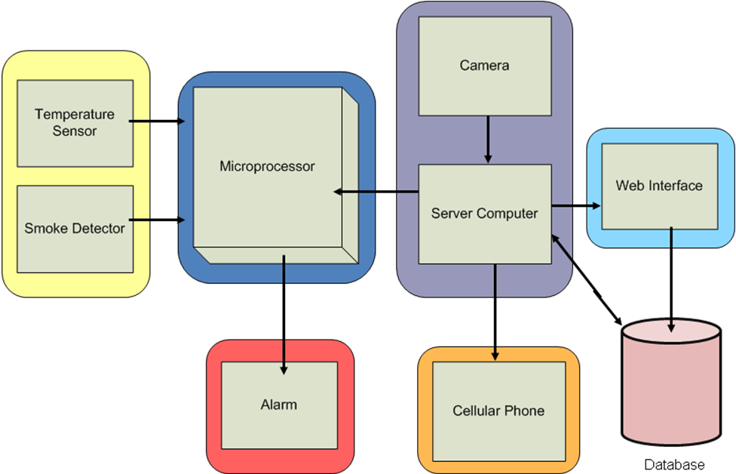

Figure 1: High-Level Block Diagram

  - Hardware

The hardware part of the system will be in charge of the environmental data acquisition that will be transferred to the software module. It will monitor the temperature for possible fire (smoke detector) and alert the rest of the system on what is the current situation in the area. The hardware will also activate an alarm whenever an unusual situation arises. For these tasks we need several sensors, a microprocessor, and a sound alarm. Additionally, the equipment will be monitored visually, so a camera will be needed. The hardware behavior is shown in Figure 2, which represents the flow chart.

    - Flow Chart

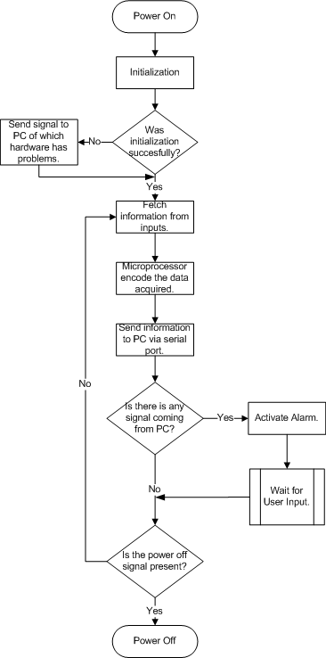
Figure 2: Hardware Flow chart

    - Solution

      - Temperature Sensors

Since there are many sophisticated types of equipment that are highly sensitive to temperature, our system will have the ability to detect if it enters on a range of danger. The following are possible solutions for the temperature sensors; thermocouples, thermistors, and RTDs.
Thermocouples are among the easiest temperature sensors to use. They are based on the See beck effect that occurs in electrical conductors when they experience a temperature gradient along their length. They are "simple", rugged; need no batteries, measure over very wide temperature ranges and more. [15]
Thermistors are tiny bits of inexpensive semiconductor materials which have a highly temperature sensitive electrical resistance. Thermistors are special solid temperature sensors that behave like temperature-sensitive electrical resistors. There are basically two broad types, NTC-Negative Temperature Coefficient, used mostly in temperature sensing and PTC-Positive Temperature Coefficient, used mostly in electric current control. A thermistor is a thermally sensitive resistor that exhibits a change in electrical resistance with a change in its temperature. The resistance is measured by passing a small, measured direct current (dc) through it and measuring the voltage drop produced. [16]
RTD’s (Resistance Temperature Detectors) are among the most precise temperature sensors commercially used. They are based on the positive temperature coefficient of electrical resistance. Resistance Temperature Detectors or RTDs for short, are wire bound and thin film devices that measure temperature because of the physical principle of the positive temperature coefficient of electrical resistance of metals. The hotter they become, the larger or higher the value of their electrical resistance. [17]
Our Possible Solution: The E52-THE5A- 0/100C is our main option because of its thermistor capabilities.

      - Fire (smoke) Sensor

The smoke sensor, like the other sensors, helps us to protect the desired equipment. This sensor has the task of detecting if there is smoke, so it will be able to detect fire. A smoke detector is a sensitive system to the presence of particles of combustion (smoke) dispersed in the air. The smoke detection system is composed mainly by a sensor, where some property measurable change in the presence of smoke, and an actuator, which activates an alarm system or security. The following are possible solutions for the fire (smoke) sensors; smoke sensors by photoelectric effect or ionization.
There are smoke sensors by photoelectric effect (called "optical"), which have a photoelectric cell where the lighting of a metal (which is affected by the presence of smoke), generates a weak flow. This kind of sensor is more sensitive to the fires of slow development (without flames). [18]
The smoke detector by ionization, as a sensor that uses camera ionization air, through which flows a small stream of ions sensitive to the presence of smoke. Such detectors reacts better to the fast development of fire (with flames), and produces less "false alarms" due, for example, to cigarette smoke. [19]
Our possible solution: The DD-4018 Smoke Detector is the sensor that will have the ability to detect if there is a smoke in the environment where the equipment is located.

      - Camera

The camera will have the task of constantly monitoring the equipment’s location. It sends the captured images to the server computer, and then the software takes the necessary action. The following are possible solutions for the cameras; CCTV, CCDP, Webcams, IP Camera, and Biometric Surveillance cameras.
The behavior of the CCTV (Closed Circuit Television) cameras is to transmit a discrete signal to a specific location rather than broadcasting it (ex. public television). This is the common system found in most areas where surveillance is needed. Most of the time there is a recording device attached to record the camera’s signal. [17]
CCDP (Close Circuit Digital Photography) is a new methodology due to the growth of digital photography. While CCTV is used more when there is a live monitoring situation like a parking lot with a guard observing monitors, CCDP is used for taking better resolution images at a lower storage cost. [20]
Web cameras are accessible to the public, where they can be found in most electronic stores at a low cost, but these cameras cannot do the work alone. Most of the time they are working along with a software program that will take decisions based on image acquisition. [21]
The IP camera will work using the existing IP protocols standards of recording and monitoring, setting a base for the IP monitoring. This method is often used at universities, private companies or places where there is a network infrastructure established (you will not see this type of equipment in local mini-markets). This technology will use the internet in the area for the signal transmission, data management and power of the camera. Due to the nature of these devices, they have more features and higher resolution than older devices. [22]
Biometric surveillance cameras are used to detect facial and human behavior. This technique uses special infrared lights and a camera with a facial recognition system that make the system capable of doing verification, identification or screening (ex. Top wanted) of any person. [23]
Our possible solution: For this system a web cam will be used since they have a higher video resolution (640 x 480) at a lower cost.

      - Microprocessors
The microprocessor will work with the communication between the other parts of the SST system. It will send the warning to the computer when one of the sensors detects any kind of danger to the equipment. The following are possible solutions for the microprocessor: T80c50, MSP430, and LM3S1968.
The T80C51 has several features like 4 K bytes of ROM, 128 bytes of RAM, 32 I/O lines, two 16 bit timers, a 5-source, 2-level interrupt structure, a full duplex serial port, and on-chip oscillator and clock circuits. [24]
MSP430 device comes in a variety of configurations featuring the usual peripherals: internal oscillator, timer including PWM, watchdog, USART, SPI, I2C, 10/12/14/16-bit ADCs, and brownout reset circuitry. Some less usual peripheral options include comparators (that can be used with the timers to do simple ADC), on-chip op-amps for signal conditioning, 12-bit DAC, LCD driver, hardware multiplier, and DMA for ADC results. Apart from some older EPROM (PMS430E3xx) and high volume mask ROM (MSP430Cxxx) versions, all of the devices are in-system programmable via JTAG or a built in bootstrap loader (BSL) using RS-232. [25]
The LM3S1968 has several features like ADC, 32-Bit RISC architecture, Real-Time Clock (RTC), serial interfaces, UART, and others. [26]
Our possible solution: The MSP430F149 is a microcontroller family from Texas Instruments. Built around a 16-bit CPU, the MSP430 is designed for low cost, low power consumption embedded applications. The architecture is reminiscent of the DEC PDP-11. The MSP430F149 is particularly well suited for wireless RF or battery powered applications.

      - Alarm

The alarm will have the task of releasing sound when the microprocessor sends the signal which means that there is some sort of danger to the equipment.

  - Software

The software integration will consist of the logic for image acquisition and comparison, retrieval and analysis of the microprocessor information along with the live streaming upload into a web interface data base. The software will signal the microprocessor if there is an emergency, so that it can active the alarm. The software behavior is shown in Figure 3, in the form of a flow chart.

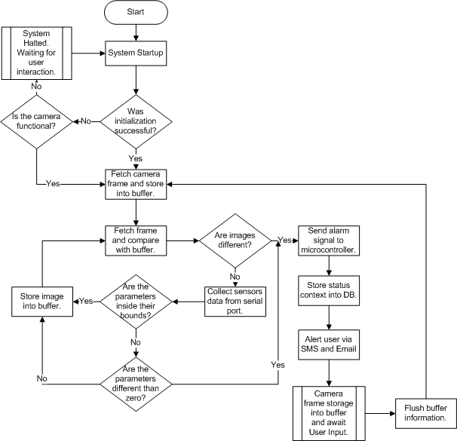
    - Flow Chart
Figure 3: Software Flow chart

    - Solution

      - Main Application Service (MAS) - The MAS will be the software in charge of the system logistic. It will be the one collecting the bit stream information from the web cam, encoding and comparing its information for the detection of movement. The service will be the one uploading the live streaming into the web server for live monitoring. Also, it will be the responsible for decoding the information provided by the microprocessor and presenting that data into the database.
      - Web Application Interface - The interface’s task is to provide quick access to a live stream channel within the application and the camera, facilitating the administrator with vital information about the current situation.
      - Database - Information about temperatures, movement behavior or smoke detection will be stored into a SQL Database making the system traceability capable.

There are possible solutions like the use of modules or subroutines in languages such as C, Java, C# and others. The software consists of modules with a main application service that will control the logic of the camera and microprocessor, a Web Page interface, letting the administrator log in and lively monitor the environment and a data base where all transactions will be stored.
Our Possible Solution: The system motion detection algorithm and communication will be done using a C# module.

- Schedule

The Gantt chart will be used to set the project’s task to each group member. It will track the task duration, percent completed and guide group members to achieve the system development on time.

  - Gantt Chart (See figure index for full size)

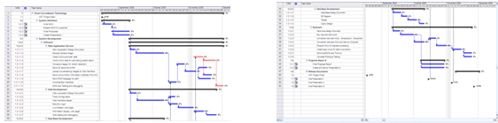
Figure 4: Refer to Figure 15, page 46 Figure 5: Refer to Figure 16, page 47

  - WBS

The following is the Work Breakdown Structure, projected by tiers (levels). The tasks of project start and finish are not taken into consideration since they are milestones. Table 1 presents a WBS Task summary. Figures 6 to 15 show the WBS structure generated by the Microsoft Project 2008 software.

Tier 1 Tasks
- System Definition
  - Write SOW
  - Present SOW to Customer
  - Write Proposal
  - Create Presentation I
Tier 2 Tasks  - System Development  - Software  - Main Application Service  - Main application design document  - Decode camera images  - Collect Microcontroller data  - Verify Micro data for alarm activation  - Compare images for motion detection  - Store 20 seconds buffer  - Upload live stream images  - Store information into DB periodically  - Send SMS Message for alert  - Administrator Interface  - Software testing and debugging  - Web Development  - Web design document  - Tools configuration  - Web design | - Security login  - Live stream web page  - Display web information  Web testing and debugging  - Data Base  - DB Design document  - ER Diagram  - Tables  - Query Design  - Hardware  - Hardware design document  - Buy required hardware  - Connection between Micro and sensors  - Connection between Micro and computer  - Program Micro for signals processing  - Create logic circuit for alarm  - Hardware/Software Tune Up  - Complete Protype
Tier 3 Tasks  - Progress Report II  - Write Progress Report  - Create and Deliver Presentation II | Tier 4 Tasks  - Release Documents  - Hardware and Software Manuals  - Final Report
Table 1: WBS Task summary

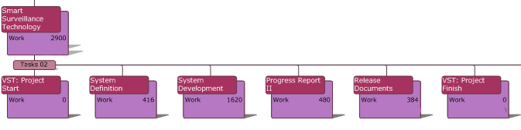
Figure 6: Top Tier Work Breakdown Structure

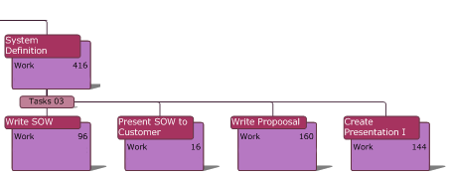
Figure 7: Tier 1.1, 1.2, 1.3, and 1.4 Work Breakdown Structure

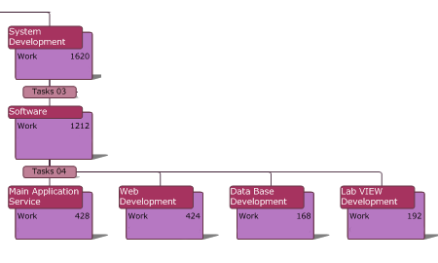
Figure 8: Tier 2 Work Breakdown Structure

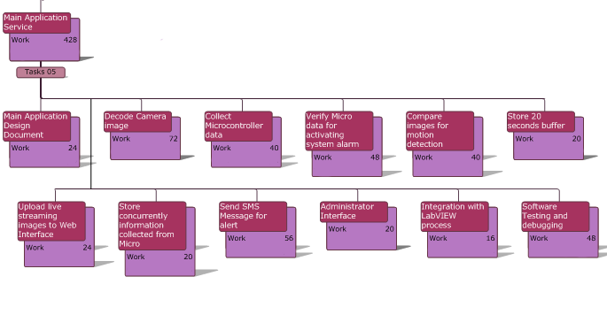 Figure 9: Tier 2.1.1 Work Breakdown Structure

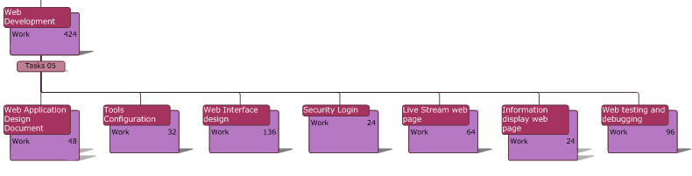
Figure 10: Tier 2.1.2 Work Breakdown Structure

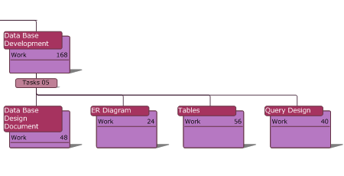
Figure 11: Tier 2.1.3 Work Breakdown Structure

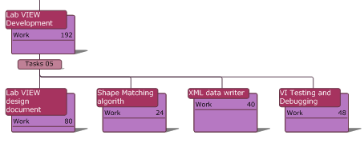
Figure 12: Tier 2.1.4 Work Breakdown Structure

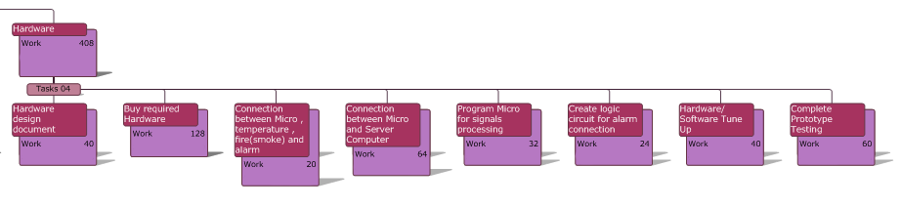
Figure 13: Tier 2.2.1 Work Breakdown Structure

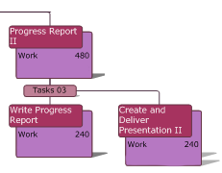
Figure 14: Tier 3 Work Breakdown Structure

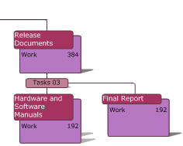
Figure 15: Tier 4 Work Breakdown Structure

- Measurability

One of the integral parts of our success is to correctly measure the progress of our system. This will be achieved by adhering to the schedule and designated task on time and by an extensive testing process. The two main components of our system are software and hardware which require different tests to verify their correct operation.

Hardware:
• Sensors – because each sensor operates with different standards we need to verify that they are working properly by using multi-meters to probe the analog signals (given in the correct scale).
• Microprocessor – to test the microprocessor we need to verify by means of serial communication that the data from the sensors is encoded and received properly by the computer. Also, check if the alarm works by sending it a signal from the computer.

Software:
• MAS – to verify the proper communication with a microprocessor we need to collect the signals received from the serial communication and decode them, if errors occur verify by repetition and adjust the triggers. Testing will be done when signals are received to see if the system reacts to the previously declared thresholds. Communication with cameras and reaction to triggers will be verified by correctly taking the snapshots, uploading, and activating the live feed. To confirm that the system is working at desired times we will set random intervals of operation to verify that it works during those times.
• Website – various tests will be done to properly connect to the database and receive data. Also, tests will be done to verify that the correct snapshots are accessed, displayed from the server, and the connection to the live feed will be checked by accessing it from the webpage. Confirmation that the SMS (text messaging) system is working properly will be achieved by receiving messages on actual cell phones.

- Risk Assessment

  - Risk Management Plan

This section presents the risks of the project as well as their corresponding mitigation, monitoring and management plans.

    - Risk A – Team members Health
      - Mitigation – Effective use of a Communication plan, team members will let other team members know when they are not feeling well and if any medical attention is needed for any of them in case of trouble (i.e. Insulin need)
      - Monitoring – Frequent use of communication mediums like email to keep other team members aware of conditions.
      - Management – In case of sickness remaining team will get together and manage task reassignment.
    - Risk B – Team member leaves group
      - Mitigation – Assign task according to each member’s semester academic load. Maintain the scope of the project and avoid procrastination.
      - Monitoring – Keep communication channels open and create a open and free environment where team members feel free to speak and let know how busy they are.
      - Management – In case no other way is found then the scope of the project should be rechecked and also the schedule and task assignment. Evaluate possible use of external resources for tasks where remaining team members are not as experienced.
    - Risk C – Hardware or Software failure
      - Mitigation – Utilize SVN for software backup and versioning. Careful use of hardware and keep team members aware of hardware specifications to avoid burning or losing equipment.
      - Monitoring – Do weekly runs where work done is analyzed and errors or problems are seen before hand.
      - Management – In the case of hardware, replacement of equipment must be done and in case of software failure possible reversion to previous version (using SVN).

    - Risk D – Conflicts between team members
      - Mitigation – Create and maintain an atmosphere of respect and openness. Treat every argument with respect and seriousness.
      - Monitoring – If an issue appears try to solve it in a timely manner without any of the parties feeling underappreciated.
      - Management – In case of situation escalates then an outside mediator could be used to resolve the conflict if the members agree to respect the mediator’s solution.
    - Risk E – Parts do not arrive
      - Mitigation – Organizing the parts needed before hand and buying them online before scheduled this risk could be mitigated.
      - Monitoring – If the parts have already been ordered then an online package tracking system like Fedex should be used to monitor where the parts are.
      - Management – In case parts are delayed or never arrive then backup suppliers should be contacted or in extreme case project would have to be delayed.
    - Risk F – Parts Failure
      - Mitigation – Team members should be careful handling parts and should read all datasheets to be informed of parts limitations. Replacements should be in hand in case failure happens.
      - Monitoring – The use of multimeters and regulators will be needed to be informed on parts status at all times.
      - Management – In case a part is burned or damaged replacements should be used and more careful handling will be in place.
    - Risk G – Hurricane and weather conditions
      - Mitigation – Create and maintain an open communication with team members and have in hand alternate mediums for communicating like home phone numbers.
      - Monitoring – Time for watching the news should be made also utilize family members and external sources (RSS feeds and weather websites) to maintain awareness of weather conditions.
      - Management – In case a situation occurs, it is not expected of each team member to be on site. A delay may be in place and team members should use the alternate mediums of communication to make sure every team member is safe.

  - Legal Constraints

SST (Smart Surveillance Technology) is being created entirely by the VST team (Vision and Security Team). For no reason anyone outside this team should have rights over it. If a person outside this group wants to have any right on it, he/she would have an interview with the team and their intentions should be accepted by each of the team members. The rights of the design and implementation of the prototype are totally property of William Sanchez Rosa, Javier Ocasio Perez, Abraham Diaz Santiago and Mariel Martinez Marrero.

Part of the software code who manages the logic of comparison between images is protected by the GNU General Public License (GNU GPL) [24]. Although that specific code was in VB and was translated into C#, GNU GPL states that source code under GPL that is used into new programs, needs to be public at any time. In order to meet the license requirements, we, VST, will publish that part of the source code in our website.

- Direct and Indirect Effects

  - Health and Safety

As a safety factor the system will be compliant with FCC regulations and will avoid emitting dangerous levels of electromagnetic radiation; this will avoid interference with any life threatening device for example medical equipment used in hospitals. Alongside a user manual will be provided to the customers explaining the appropriate use of the system, so that no health or safety issue should arise if the instructions are followed.

  - Environment

The hardware components of the system should be compliant with the RoHS directive which stands for "the restriction of the use of certain hazardous substances in electrical and electronic equipment". The directive bans the placing on the EU market of new electrical and electronic equipment containing more than agreed levels of lead, cadmium, mercury, hexavalent chromium, polybrominated biphenyl (PBB) and polybrominated diphenyl ether (PBDE) flame retardants. In order to avoid environmental problems during the disposal of the system, dangerous materials will be avoided. This minimizes the risks to the environment and human life in the future.

  - Ethical Considerations

Privacy issues arise when personnel are under video surveillance, but as in any private institution personal areas will not be monitored; this includes bathrooms, restrooms, and lockers. Our system’s purpose is to monitor equipment, not people. Therefore, proper signs will be placed in the areas under video surveillance to warn the users beforehand.

Modular Behavior
Our system breakdown consists of three different modules: main software, Microcontroller and web interface. If one of the three modules has problems, it will not affect the logic and behavior of the other modules, making it less dependent from others, simple in maintenance and a more sustainable system.

- Personnel Background

  - Biographies

Mariel Martinez Marrero

Mariel Martinez Marrero is a Computer Engineer student from the University of Puerto Rico at Mayaguez. Her specialization is in hardware. She has experience working with digital electronic, integrated circuits, analog circuits, logic circuits and electronic system analysis and design. She also has experience working with different programming languages like C, Java and Assembly. She has also worked on the design and analysis of the project DAC (Digital to Analog Converter) using the Cadence tool and also worked on the design and implementation of a power supply.

In this project she will be in charge of the design and implementation of the hardware device like the communication of the microprocessor with the other hardware components.

William Sanchez Rosa

William Sanchez Rosa is a Computer Engineer student from the University of Puerto Rico at Mayagüez. He is adept in programming languages like JAVA, C, C++, C#, SQL, PHP, ASP, and VB6. During Fall of 2007, he formed part of the research team of WIMS Cochlear implant, with the integration of the microprocessor INTEL 8051 interacting with Lab VIEW modules. William worked for Medtronic Puerto Rico Operation Company during the spring 2008 where his main work was the development of automated software solutions related to visual inspection. William has taken the necessaries CAPM (Certified Associate in Project Management) requirements for the examination, where he plans to take on November and a 24 hour course of Data Base Administrator, learning all basics aspects of the material.

William will be main developer in the modules that integrates camera image acquisition and storage, and the communication between the main software and the microprocessor. He will also be in charge of the unit testing of the software application that interacts with the microprocessor.

Javier Ocasio Perez

Javier Ocasio Perez is a Computer Engineer student from the University of Puerto Rico at Mayaguez. His specialization is in software. Javier has experience programming with C, Java, C#, Lab View, SQL and Assembly. During the summer of 2006, he was part of the Florida International University Research Experience for Undergraduate (REU) Program, where he developed a GUI for the TRAP.NET adaptive software project using Visual Studio and .NET technologies. In the summer of 2007, Javier formed part of the Summer Institute in Engineering and Computer Applications (SIECA) in the NASA Goddard Space Flight Center in Greenbelt, MD. There Javier developed an application to control a temperature chamber using Lab View. During the spring and summer of 2008, Javier worked for NASA Goddard Space Flight Center, as a Co-op student, where he developed test scripts for the Micro-shutters subsystem of the James Webb Space Telescope.

Javier will be the Project Manager. He is responsible for the distribution of work, monitoring of the completion of work on time, efficiently planning meetings, making a project plan, and other documentation for the project. Javier will also be involved in the testing of the hardware parts of the project, as well as help in the development and testing of the software modules.

Abraham Diaz Santiago

Abraham Diaz Santiago is a Computer Engineer student from the University of Puerto Rico at Mayaguez, with a focus in Software Development. His area of expertise is on Web Applications and customer solutions. He have worked with many programming languages such as Java, C#, C++ and other low level languages like assembly. He has experience in the development of databases and web interfaces. He has worked on many projects like Digital to Analog Converters (6 bits) as integrated solutions, USB Hijacking (hardware utilization for system exploitation) and microprocessors emulation. He had professional experience with Deloitte Consulting LLP creating software solutions for the “Customer and Markets” division. Outside from work he tries to help out in community service activities and help out organizations like the Boy Scouts of America.

Abraham will be in charge of the implementation of the system’s web interface and the development of the data base.

  - Technical Knowledge

In order to develop this project in a successful system, team background needs to match the project needs.

• Project Manager
The project manager should keep the agenda up date, stay alert whenever there is a huge change of plans in order to counter and mitigate that effect. Skills that he/she must need must resemble those of responsible, alert in tight decisions, proactive and a quick thinker. Is his full responsibility that the project does not lag behind and that milestones are achieved.

• Web Developer
A person with web development expertise is needed as the system requires a web interface for live streaming along with a data base. For web development, background in ASP, PHP, .NET Frameworks and Visual Studio among others, are skills that team members who are going to develop this part of the project needs. Also, MySQL data base skills will be required in order to store and retrieve data from it.

• Hardware: Microcontrollers
The MSP430F149 microprocessor used in this system requires a specialist on the microprocessor area. This person will need to know the basics of microprocessor programming along with ideas and decisions for logic circuit creation. Skills like current or voltage divisions, amplification of voltage or activating a microprocessor signal at a given time or by other signal’s response are some of the requirements of the persons who will be working in this area.

• Software and Image Acquisition
The Main Application Service (MAS) is going to be the main logic of the application. This person will require basic knowledge in getting information from the microprocessor, the ability to use data base connection and microprocessor’s information storage. It will also require expertise in the image acquisition comparison in order to verify movement in the image. The person will also need skills in C#, .NET, and serial ports.

- Budget

The budget is based on our possible hardware parts that are considered as solutions at the moment. The analysis consist four parts: personal, hardware, software and miscellaneous costs. The personal resource analysis consists on a monetary breakdown about how much each member of the team will cost according to their respective major. Hardware cost research was a crucial part of the development of the system. The team verified, among all the different cameras, sensors, smoke detectors, alarms and microprocessors, the one that better fitted the environment for this type of system to be implemented. Software budget justification is more oriented to which tools are to be used in the development. Costs like shipping and handling, transistors, cables, and other tools for the circuit assembly will be described in detail in the miscellaneous part.

  - Personal Engineer Resources

Vision and Surveillance Team will need the hire of 3 Engineers and a Project Manager for the development of the Smart Surveillance Technology (SST). The following information was obtained from salary.com with the following constrains: company size less than 25 employees and an industry related to software and networking.
A Software Engineer I has an average year salary of $43,000.00 equivalent to $20.83 per hour salary. A Hardware Engineer I has an average year salary of $47,600.00, for an equivalence of an hourly wage of $23.06. A Project Manager I has an average yearly salary of $54,100.00 equivalent to $26.21 per hour salary. SST development timeline will take from September 10, 2008 to December 1, 2008, a total of 12 weeks; 60 days. In that time, there is a total of 5 holidays, lowering the total of working days to 55 days. Each resource will work 15 hours weekly for a total of 165 hours (55 days * 3 hours) in 12 weeks. The following is the salary breakdown.

Employees | Position | $/Hour | Total Hours | Expected Salary
William Sanchez | Software Engineer I | $20.83 | 165 | $3,436.95
Abraham Diaz | Software Engineer I | $20.83 | 165 | $3,436.95
Mariel Martinez | Hardware Engineer I | $23.06 | 165 | $3,804.90
Javier Ocasio | Project Manager I | $26.21 | 165 | $4,324.65
 |  | Total Employment Salary |  | $15,003.35
Table 2: Total Employment Salary

  - Hardware

Research was made according to our needs and various possible solutions were available. At section 4.1 of this proposal, for each hardware topic, there is a list of different types of devices that were considered as an option for our development. The system will require the acquisition of various components: a microprocessor, an alarm, a heat sensor, smoke detector, and a camera.

Component | Description | Qty. | Price | Cost
Microprocessor | DEV-00046 Header Board for MSP430F149 | 1 | $22.95 | $22.95
Cable for Programming | MSP-JTAG Parallel Port Programmer | 1 | $14.95 | $14.95
Alarm | 130db Personal Security Alarm | 2 | $11.99 | $23.98
Heat Sensor | E52-THE5A- 0/100C | 2 | $30.47 | $60.94
Smoke Detector | DD-4018 Smoke Detector | 2 | $29.38 | $58.76
Camera | Hercules 4780465 1.3 MP | 1 | $21.99 | $21.99
 |  | Total Hardware Cost |  | $203.57
Table 3: Total Hardware Cost

  - Software

Most of today’s tools used for software development are open source. Some of those programs are Eclipse, Net beans, Visual Studio Expresses Editions, Aptana Studio, among others. Looking from our system’s needs and environment that it will be connected, we decided to use Microsoft .NET Framework. Both web application servers and the main logic controlling the monitoring system will be using Microsoft operating system (Windows XP). Using that point in our favor, and for making the interoperability of both monitoring service and web server more stable, we decided to use C# .NET and ASP.NET. The development tool that supports these programming languages is the Visual Studio Express Editions.
The language used for data base manipulation is SQL, which is the one compatible with the server scripting handling. For this scenario, MySQL service Tools bundle will be used.
Programs | Quantity | Price | Cost
Visual Studio 2008 Express Editions | 3 | $0.00 | $0.00
MySQL GUI Tools | 3 | $0.00 | $0.00
MySQL Server | 3 | $0.00 | $0.00
Microsoft IIS 7.0 | 1 | $0.00 | $0.00
Kick start Workbench | 1 | $0.00 | $0.00
 | Total Software Cost |  | $0.00
Table 4: Total Software Cost

  - Miscellaneous

Miscellaneous cost includes those expenditures that do not directly form part of either hardware or software.
Miscellaneous Expenditures | Quantity | Price | Cost
Hardware’s Shipping and Handling | 1 | $21.50 | $21.50
Electrical Devices Kit | 1 | $20.00 | $20.00
Web page domain (vstsolutions.info) | 1 | $2.14 | $2.14
Web Page Monthly Fee | 5(months) | $4.95 | $24.75
 | Total Miscellaneous Cost |  | $68.39
Table 5: Total Miscellaneous Cost

  - Overall Cost

Many factors were considered in order to calculate the overhead of our project. According to our schedule, we computed the days left for the dead line, and adjusted it using the estimate billable direct labor hours. Other factors that were used for this calculation were direct labor days, labor dollars, hourly wage, business expenses, and materials among others. Using the procedure located at ‘http://www.missouribusiness.net/docs/calc_overhead_percentage.asp’, we determined that the overhead for this project was 73%.

Category | Cost
Salary | $15,003.35
Hardware | $203.57
Software | $0.00
Miscellaneous | $68.39
Project Cost | $15,275.31
73% Overhead | $11,150.98
Total Project Cost | $26,426.29
Table 6: Total Project Cost

  - Single Unit Cost
After the initial prototype development, subsequent system’s research and development costs won’t be included. This means future releases will cost less. It will be taken into consideration that the system requires two days- man work for installation. Outsourcing the personal that is going to make the system deployment, will reduce cost, rather than doing ourselves the installation. According to salary.com, personal’s annual income of Network Service Representative I, is around $24,000.00 ($11.90/hr). Estimating 2 day- man work payload at 4 hour per day will result in an installation cost of $190.40 (rather than $333.28). In the miscellaneous, aspects like the web page domain and monthly fee will not be taken into considerations, since the system deployment will be in the client private server. Following is a breakdown of the single unit cost.

Category | Cost
Salary | $190.40
Hardware | $116.78
Software | $0.00
Miscellaneous | $41.50
Total Project Cost per unit | $348.68
Table 7: Total Project per unit cost

  - Expected Sale Price

Analyzing our single unit cost, an expected sale price can be calculated, taking into consideration the market competition. For this analysis, the Sensorsoft©[8] system will be the one taken for our system comparison since their features are similar, as stated on the Market Description section. Our cost includes the following features: the main software system, a camera, a heat sensor, a smoke (fire) detector, and a microprocessor. In order to do a fair comparison, we must include the following Sensorsoft features: a camera, a heat sensor, the main application, and since they do not have smoke detector, we will be using a humidity sensor for the analysis. The following is a sale price breakdown from Sensorsoft.

Sensorsoft Features | Sale Price
Remote Watchman Enterprise 2005 | $750.00
Sensorsoft Humidity Temperature | $199.99
Axis 207 Network Camera | $283.00
Total Price | $1,232.99
Table 8: Sensorsoft Total Price

The system previously described, has the ability to monitor up to either ten sensors and/or cameras, thus, constraining the system. Our base of sale price is $348.68, since is our unit cost and selling the system at a lower price will cause profit loss. The team has established a selling strategy, which is, to cover the unit cost of the system and be able to gain enough capital to produce another. In order to obtain a profit gain of 100%, it has been established to come with a competitive selling price of $700.

- References

[1] Tens of thousands of CCTV cameras, yet 80% of crime unsolved (2008)
Retrieved 08 17, 2008, from This is London Magazine Ltd. http://www.thisislondon.co.uk/news/article-23412867-details/Tens+of+thousands+of+CCTV+cameras,+yet+80%25+of+crime+unsolved/article.do

[2] ‘Querrellas Reportadas en el RUM’. (2008)
Retrieved 08 17, 2008, from ‘Oficina de Calidad de Vida’ http://calidaddevida.uprm.edu/delitos.html

[3] British Transport Police launches new London Underground Neighborhood Policing Teams (2008). Retrieved 08 11, 2008, from London Press Release: http://www.london.gov.uk/view_press_release.jsp?releaseid=18115

[4] IP Surveillance (2006). Retrieved 08 11, 2008 from Skynet Broadband Solutions
http://www.skynetip.com/solutions.php?solution=ipsurveillance

[5] Surveillance solutions for real-time situational awareness. Retrieved 08 11, 2008 from
Aptina Imaging
http://www.aptina.com/solutions/surveillance.jsp#overview
[6] Black & White Indoor CMOS Camera w. Five IR LEDs. Retrieved 08 11, 2008 from
TowerMicro
http://www.towermicro.com/index.php?page=shop.product_details&flypage=details.tpl&product_id=1868&category_id=1028&option=com_virtuemart&Itemid=217

[7] Web Ready DVR System w/ 4 Outdoor Nightvision Cameras. Retrieved 08 11, 2008
fromTowerMicro
http://www.towermicro.com/index.php?page=shop.product_details&flypage=details.tpl&product_id=1862&category_id=1028&option=com_virtuemart&Itemid=217
[8] Sensorsoft Thermometer and Remote Watchman Client Package. Retrieved 08 11,
2008 from Sensorsoft Corporation.
http://www.sensorsoft.com/pricingpage.html

[9] Network monitoring services. Retrieved 08 11, 2008 from n-Frame
http://nframe.com/monitoring_equipment.html

[10] EyeLine Professional Video Surveillance Software. Retrieved 08 11, 2008
from NCH Software
http://www.nchsoftware.com/software/index.html

[11] Inventory Procedures for sensitive equipment. Retrieved 08 11, 2008 from
University of Maryland Libraries
http://www.lib.umd.edu/PASD/LPO/AdminMemos/memo23.html

[12] Surveillance Equipment (2008) Retreived 09 2, 2008,
from ‘surveillanceequipment.us’
http://www.surveillanceequipment.us/

[13] X10 Home Camera Surveillance. Retrieved 08 11, 2008 from X10 home solutions
http://www.x10.com/key_products/home-camera-surveillance.htm

[14] Video Surveillance Systems. Retrieved 08 11, 2008 from ProTech Computer
Services
http://www.protechcomputer.com/Surveillance.htm

[15] Thermocouple. Retrieved 08 11, 2008 from temperatures.com
http://www.temperatures.com/tcs.html

[16] Thermistors. Retrieved 08 11, 2008 from temperatures.com
http://www.temperatures.com/thermistors.html

[17] RTDs. Retrieved 08 11, 2008 from temperatures.com
http://www.temperatures.com/rtds.html

[18] “El detector de Humo” by José Luis Giordano May 2004. Last Revision April 2,
2006. Retrieved 09 7, 2008
http://www.profisica.cl/comofuncionan/como.php?id=11

[19] Closed-circuit television by Wikipedia. Retrieved 09 7, 2008
http://en.wikipedia.org/wiki/CCTV
http://ipvideomarket.info/topics/VideoSurveillance

[20] Webcam by Wikipedia. Retrieved 09 7, 2008
http://en.wikipedia.org/wiki/Web_camera

[21] IP Camera by Wikipedia. Retrieved 09 7, 2008
http://en.wikipedia.org/wiki/IP_Camera
http://www.jvsg.com/software/ip-video-system-design-tool/

[22] Surveillance by Wikipedia. Retrieved 09 7, 2008
http://en.wikipedia.org/wiki/Surveillance

[23] TSC80C31/80C51 from Temic Semiconductors datasheet Rev. E (14 Jan.97).

[24] MSP430F149 Mixed Signal Microcontroller by Texas Instruments datasheet.
Revised June 2004

[25] LM3S1968 Microcontroller datasheet from Luminary Micro

[26] The GNU General Public License (GPL) by Open Source Initiative. June 1991
http://www.opensource.org/licenses/gpl-2.0.php

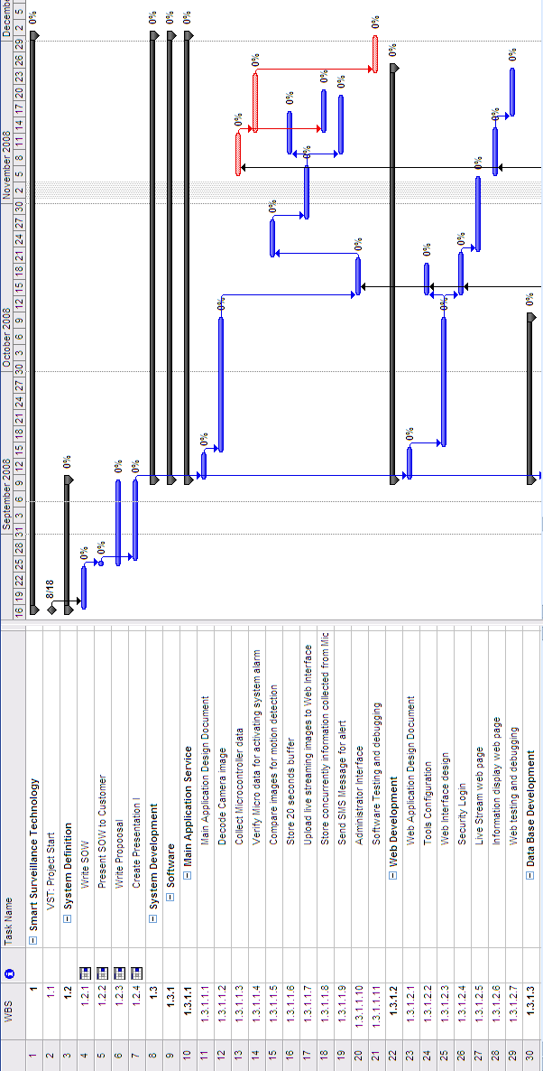
Figure 15: Gantt chart Part 1

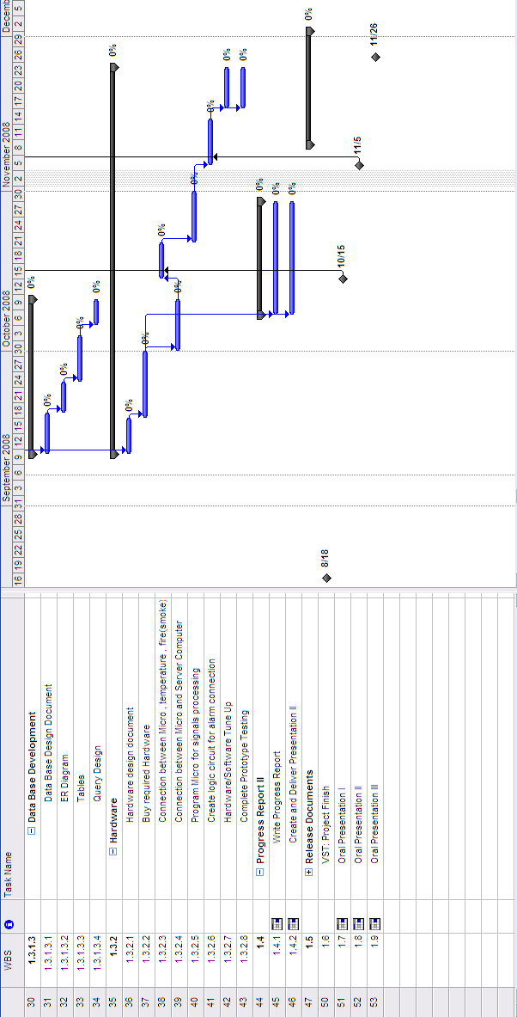
Figure 16: Gantt chart Part 2

